ESP32-A1S Module

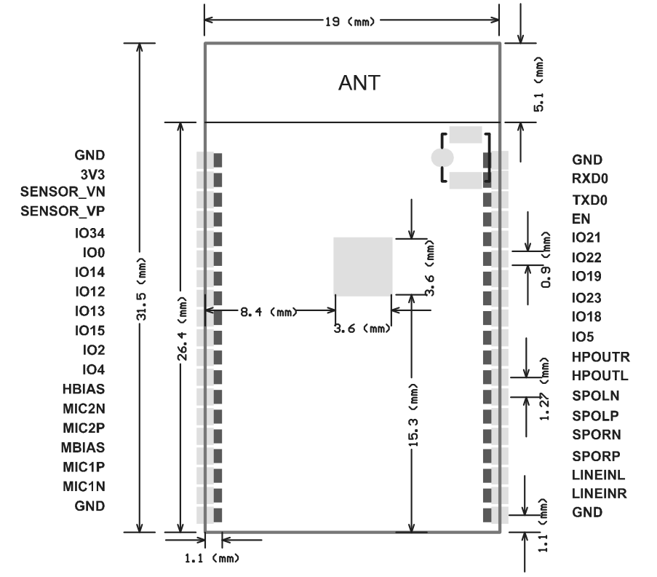
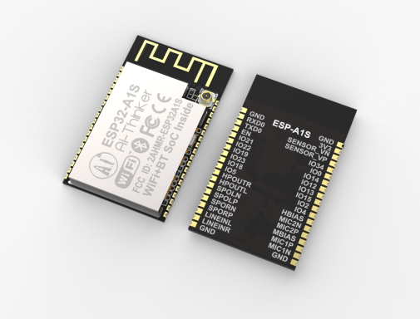

Overview
Features
ESP32-A1S is an ultra-small, powerful module. Built-in advanced low-power dual-core 32-bit CPU and Codec AC101 audio decoding chip, can be widely used in various IoT applications, suitable for home smart devices, smart Audio, story machine solutions, etc., are the ideal solution for IoT applications.
ESP32-A1S internal circuit is highly integrated, supports a variety of peripherals, can support secondary development, and quickly realize product differentiation.
ESP32-A1S adopts SMD package to realize rapid production of products and provide customers with high-reliability connection mode. It is especially suitable for modern, large-scale, low-cost production methods, and is convenient for various IoT hardware terminal applications.
- The smallest 802.11b/g/n Wi-Fi BT SoC Module
- Low power 32-bit CPU,can also serve the
application processor
- Built-in AC101 Codec audio decoding chip, can support playing music and recording
- Built-in 520 KB SRAM, external 4MPSRAM
- Supports UART/SPI/I2C/PWM/ADC/DAC
- Support for firmware upgrade (FOTA)
- Antenna supports on-board antenna or IPEX block output
- Supports a variety of mainstream compression and lossless audio formats, including M4A, AAC, FLAC, OGG, OPUS, MP3, WAV, etc.
- Supports audio input methods such as MIC and Line-in.

Product Specifications
Module Model | ESP32-A1S
Package | SMD-38
Size | 32mm*19mm*3mm
SPI Flash | Default 32Mbit
RAM | 520KB SRAM +4M PSRAM
Bluetooth | Bluetooth 4.2 BR/EDR and BLE standards, support A2DP, AVRC protocol, etc.
Wi-Fi | 802.11 b/g/n/， Support DLNA protocol
Audio Output | Support 1 channel headphone output and 1 channel left and right speaker output
Audio Input | Support LINEIN and 2-way MIC input
Custom IO port | 14
UART Baudrate | Default 115200 bps
Audio Format | MP3、WAV、M4A、AAC、FLAC、OGG、OPUS
Antenna | Onboard PCB antenna or IPEX antenna
Transmit Power | 802.11b: 17±2 dBm (@11Mbps)  802.11g: 14±2 dBm (@54Mbps)  802.11n: 13±2 dBm (@MCS7)
Receiving Sensitivity | CCK, 1 Mbps : -90dBm  CCK, 11 Mbps: -85dBm  6 Mbps (1/2 BPSK): -88dBm  54 Mbps (3/4 64-QAM): -70dBm  MCS7 (65 Mbps, 72.2 Mbps): -67dBm
Power Dissipation | 350mA
Security | WPA/WPA2/WPA2-Enterprise/WPS
Power Supply Range | 3.3V±0.3V
Operating Temperature | -20 ℃ ~ 85 ℃
Storage Environment | -40 ℃ ~ 90 ℃ , < 90%RH
Weight | 2.5±0.05g

Module pin definition
6/5000
Mó zǔ guǎn jiǎo dìngyì
Module pin definition

GPIO | Features | Types | Remarks
TXD0 | GPIO1/CLKOUT2 | I/O | Download serial port
RXD0 | GPIO3/CLKOUT3 | I/O | Download serial port
EN |  | I | Reset function
IO21 | U0CTS/VSPIQ | I/O
IO22 | U0RTS/VSPIWP | I/O
IO19 | VSQIQ/U0CTS | I/O
IO23 | VSPIIDHS1STROBE | I/O
IO18 | VSPICLK/HS1DATA7 | I/O
IO5 | VSPICS0 | I/O
HPOUTR |  | O | Headphone output
HPOUTL |  | O | Headphone output
SPOLN |  | O | Speaker left channel output
SPOLP |  | O | Speaker left channel output
SPORN |  | O | Speaker right channel output
SPORP |  | O | Speaker right channel output
LINEINL |  | I | Headphone input
LINEINR |  | I | Headphone input
SENSOR_VN | GPIO34/ADC1_3RTCIO3 | I
SENSOR_VP | GPIO36/ADC1_0/RTCIO0 | I
IO34 | ADC1_6/RTCIO4 | I
IO0 |  | I/O | Must be hanging when using internal codec
IO14 | ADC2_6/RTCIO16/SDCLK/HSPICKJ/HS2CLK | I/O
IO12 | ADC2_5/RTCIO15/HSPIQ/SDDATA2/HS2DATA2 | I/O
IO13 | ADC2_4/RTCIO14/HSPIID/SDDATA3/H2DATA3 | I/O
IO15 | ADC2_3/RTCIO15/HSPICS0/SDCMD/HS2CMD | I/O
IO2 | ADC2_2/RTCIO12/SDDATA0/HS2DATA0 | I/O
IO4 | ADC2_3/RTCIO10/HSPIHD/SDDATA1/HS2DATA1 | I/O
HBIAS |  | O | MIC2 control pin
MIC2N |  | I | MIC2 input
MIC2P |  | I | MIC2 input
MBIAS |  | O | MIC1 control pin
MIC1P |  | I | MIC1 input
MIC1N |  | I | MIC1 input

Strapping pin

System startup mode
PIN | Default | Normal operation | Download
GPIO0 | Pull up | NC | 0
GPIO2 | Pull down | Irrelevant item | 0
Built-in LDO (VDD_SDIO) voltage
PIN | Default | 3.3V | 1.8V
MTDI/GPIO12 | Pull down | 0 | 1

Note: the built-in flash working voltage is 3.3 V, and the model chip with built-in flash needs to pull down or suspend the MTDI when it is powered on.

SHAPE \* MERGEFORMAT

Module schematic

ESP32 AC101 I2SPin connection
AC101 | ESP32
I2S_SDOUT | IO35
I2S_SDIN | IO25
I2S_LRCK | IO26
I2S_BCLK | IO27
I2S_MCLK | IO0
ESP32 AC101 I2C Pin connection
AC101 | ESP32
SCL | IO32
SDA | IO33
SHAPE \* MERGEFORMAT

Minimum system diagram

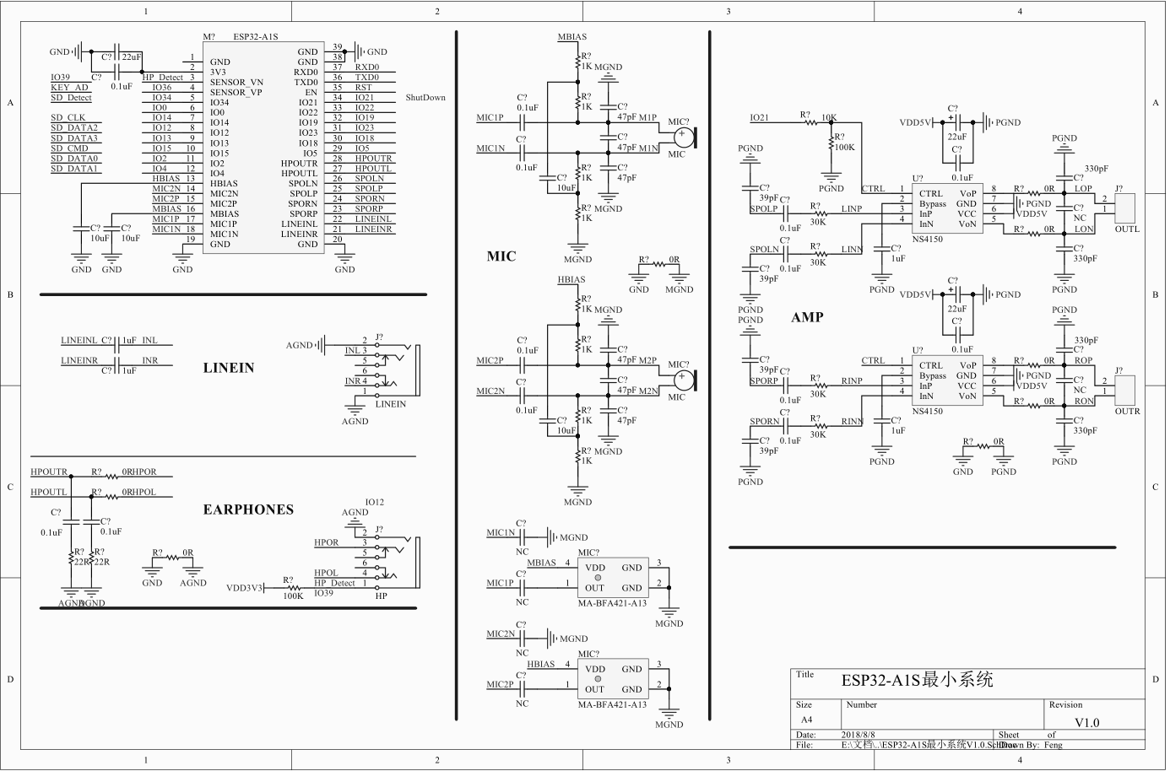

Download
http://wiki.ai-thinker.com/esp32-a1s

Shenzhen Ai-Thinker Technology Co., Ltd
Address: 7/F, Fengze Building B, Huafeng Industrial Park 2th, Hangkong street,Xixiang Raod, Baoan, Shenzhen China
Website:www.ai-thinker.com Tel：0755-29162996 E-mail:support@aithinker.com
Contact US

